GSON Implementation in JCN

**What is GSON?**

Google GSON is a simple Java-based library to serialize Java objects to JSON and vice versa. It is an open-source library developed by Google.

**When to use GSON?**

GSON is open source Java based library which facilitates serialization of Objects to JSON and vice versa, Also its Standardized, Very Efficient etc.

**How to implement GSON in IIB code with JCN (Java Compute Node)?**

**Step1:** Download the latest gson jar from central repository.

<https://repo1.maven.org/maven2/com/google/code/gson/gson/2.8.2/>

**Step 2:** Import the gson jar within your workspace and add that in Java build path

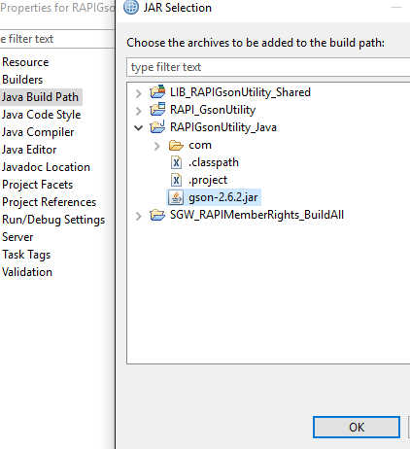

**Step 3**: We are all set we need start creating the bean class for each JSON request we interested in.

* Define Java class with Json elements and Getter &setter, Generate to string method.

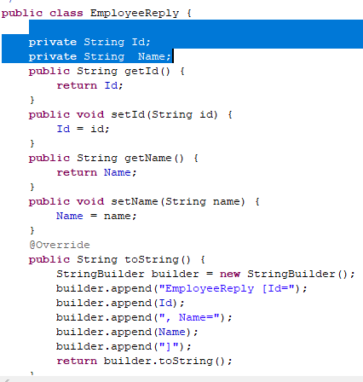

**Step 4**: Create a Utility class to access all Gson methods within the JCN. We can keep on adding utility method to make our code easier.

Here we have created serialize and de serialize methods which take input message and bean class for transformations.

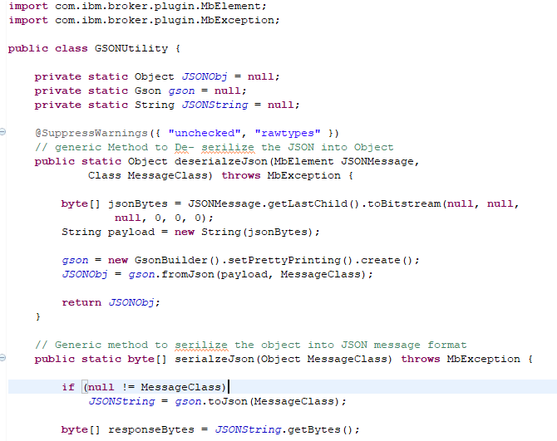

**Step 5**: Now job becomes easier as we all need do is call required method and pass the incoming message and the class.

Ex: For Employee Bean class we will be passing input message into reserialize method and map out output then serialize it by doing so we can avoid intermittent conversion of input message into byte vice versa.

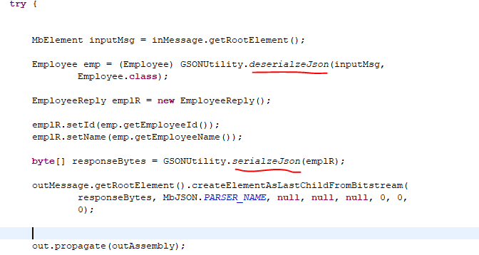

**Step 6:** It’s time to test our utility class with sample request,

* Create Simple flow With HTTPInput and reply node with JCN and provide URL path and set other required properties and deploy the service.

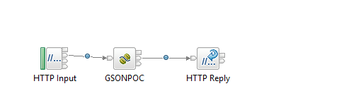

* Create sample Employee JSON message for which we created bean class

{

"employeeId": "123456",

"employeeName": "Jana"

}

* Create REST project in SOAP UI or Postman and invoke the deployed service with given URL. We should get **EmployeeReply** bean class in JSON format.as below

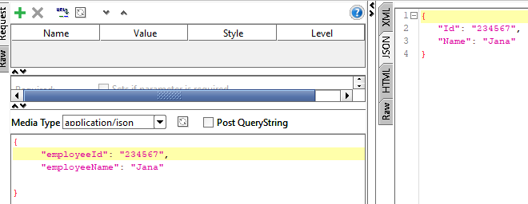

With the testing we come to end of the GSON Implementation in JCN ,Utility can used across the JSON Application and we can improve the Utility class by adding more method into it.